You are a Vice President of Strategic Alliances at WonderWorld, a producer of candy. You are contemplating entering into an alliance with one of two candidates. With company A, a producer of children’s animation movies, the goal is to use the movie’s main characters to promote the candy. With company B, a supplier of one of the main ingredients, the idea is to set up a just-in-time supply relationship to lower inventories. Which alliance would be easier to manage?

When discussing the synergy operators in Section 2, we noted that these provide potential benefits from jointly operating two businesses. Yet, collaboration does not automatically arise if there are synergies. There are impediments to be overcome and these generate costs, which we refer to as governance costs. Governance costs are the frictions that prevent two businesses operating smoothly together to realize synergies. They act as “taxes” that eat into the potential benefits from synergies when they are attempted to be extracted.

Governance costs along with synergies constitute two of the most important concepts in corporate strategy. The reason is that together they determine governance structure—the choice about joint or separate ownership of businesses between which there are synergies. The fundamental idea linking these concepts can be stated very simply: to exploit a potential synergy, pick a governance structure that unlocks the most value net of the costs of governance. In the next section of this Document (“Decisions about portfolio composition”, Sections 4 through 9), we analyze in great detail how synergies and governance costs impact decisions on the ownership choices of the corporation (e.g., whether to ally or acquire, grow inorganically or organically, or whether to outsource or insource). In this Section we highlight the origins of governance costs.

Where do governance costs come from?
Governance costs are the costs of achieving effective collaboration, over and above the direct cost of what is being exchanged. The governance costs that arise under common ownership are referred to as the ownership costs. The governance costs that arise in interactions between independent firms are referred to as transaction costs. In both cases governance costs arise from impediments to cooperation and coordination (which are both necessary for successful collaboration) and the measures needed to control these (see Figure 3.1). The magnitude of governance costs typically differ by type of synergy.

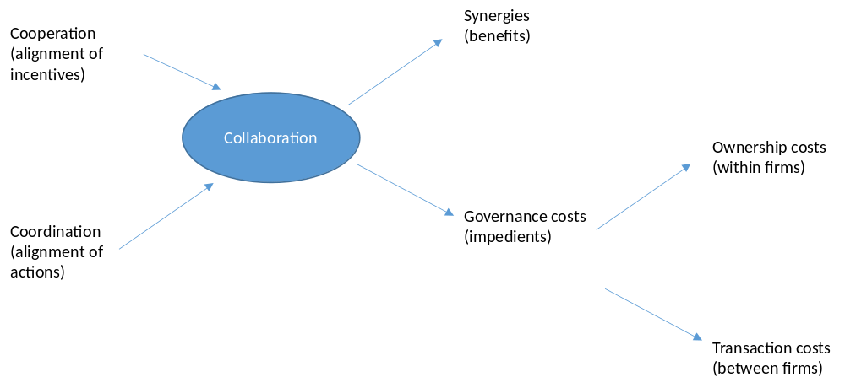
Figure 3.1 Governance costs and collaboration

Cooperation is the alignment of incentives to ensure that people are motivated to work together. When collaborating, businesses may care more about what is good for their own business rather than for the other business. Failures of cooperation are more likely if there is no shared future (e.g., two alliance partners know that the current joint R&D project is the last one), incentives are narrow (e.g., employees are rewarded on the basis of their own division’s performance rather than on the performance of the company as a whole), or if synergies are one-sided (i.e., benefits to collaboration accrue to one party only). Examples of governance costs incurred to encourage cooperation between independent businesses include drafting contracts, monitoring suppliers, resolving price disputes, haggling about product quality, and enforcing contracts through a court if necessary. The direct cost of cooperation failures include shirking, free-riding, cheating and misrepresentation.

The other source of governance costs lies in possible failures of coordination. By coordination we mean the alignment of actions so that people know how best to work together. Human problem solvers often lack complete information, may not use the available information correctly, and more generally are imperfect at processing complex information. Consequently, delays, mistakes, and miscommunication can arise between people even if they are motivated to work together.

Failures of coordination are more likely if working across different geographical locations or time zones (e.g., an IT department that is offshored from France to the Philippines), different professions (e.g., an alliance between two IT companies vs. an alliance between an IT company and an advertising company), or without a shared past (e.g., you may be unfamiliar with the other party’s standard procedures). Examples of transaction costs incurred to facilitate coordination between independent businesses are lengthy meetings, elaborate project manuals and documents, appointing coordinator roles such as key account managers, and of course rectifying mistakes when discovered. The direct costs of coordination failures are the costs of miscommunication, mis-understandings and delays.

The link between governance costs and synergies
In Section 2 we distinguished between those synergies that require modification (Consolidation and Customization) and those that do not (Combination and Connection). A key premise in our approach to corporate strategy decisions is that the governance costs of collaboration between independent businesses will typically be higher for synergies that need modification or are one-sided. There is a robust body of evidence from carefully conducted research studies that supports this premise.

To see the logic for this premise, consider the following: failures of cooperation (i.e., incentive misalignment) typically occur in situations in which one party comes to depend significantly on another. For instance:
  - A agrees to share manufacturing facilities with B and gets rid of its own factories, in order to generate synergies through Consolidation; subsequently B does not provide access to B’s factories to A.
  - A relies on a single supplier B for a key specialized input that generates synergies through Customization, with no ready alternative; B then raises the price for providing inputs to A.

In principle one could create contractual agreements to prevent the problems noted above, but the costs of agreeing on such an agreement (given that potentially one side could end up with a significant loss), or having to enforce it when there is a suspected breach, are governance costs.

Failures of coordination (e.g. misunderstandings, miscommunications, and delays) are typically situations of high interdependence in which the parties involved need to interact and communicate in order to make sure their actions are aligned to each other. For instance,
  - A agrees to share manufacturing facilities with B as between them they have excess capacity; A and B’s production planning must be fully integrated and synchronized so that there are no delays or inventory problems, and they can exploit gains from Consolidation.
  - A relies on B to create a specialized input. B must understand the nuances of the unique requirements of A in order to create synergies through Customization; alternately A and B create a component each for a product, and the product quality improves enormously when both customize their components to each other. In each case A and B’s employees must work closely together to achieve this.

It is because communication and interaction between individuals from different business is fraught with difficulties that the situations above are likely to incur governance costs. It is not a co-incidence that both the synergy operators in the examples above, Consolidation and Customization feature significant need for modification and create greater benefits for one side than another, because that is what creates the dependency and the need for interaction.

Thus while in principle two firms pursuing Combination or Connection synergies may also find it difficult to agree on the extent and distribution of value that will be created, since they incur minimal costs of modifying their resources, at worst they are left no better off if the agreement is breached. With Consolidation and Customization, they could be left worse off. Similarly the need for coordination, and consequently the danger of coordination failure is lower when neither firm needs to modify its current activities to a significant extent (as would be the case in Connection or Combination synergies).

Cooperation and especially coordination difficulties naturally are amplified when operating internationally. For example, misunderstandings, miscommunications, and delays are all more likely if your partner is in a different country, with a different language, with a different culture, and in a different time zone. Cooperation difficulties are also more likely if national boundaries create in- vs outgroup dynamics or if misunderstandings get incorrectly attributed to cooperation failures and these mistaken perceptions can become self-fulfilling, in that neither side wants to cooperate anymore.

The link between governance costs and governance structure
Governance costs vary not only by synergy but also by governance form. In fact for a corporate strategist, differences in governance form primarily signal differences in their governance costs.

Let us consider more closely the two very basic (and polar opposite) governance structures to link two businesses with potential synergies between them: common ownership and arms-length trade between separately owned businesses. In Section 5 we will introduce an entire continuum of governance structures between these two cases, but for present purposes, a consideration of the two extreme ends of this continuum suffices. The optimal choice of governance structure depends on a comparison of the governance costs for each structure, for a given type of synergy. But why should the governance costs vary across these governance structures?

Common ownership for a group of businesses means that ultimately each business is administratively controlled by the group CEO and the assets are owned by the shareholders. In most legal regimes, courts do not interfere in disputes between the internal divisions of a corporation. It is up to the CEO (and his or her delegates) to resolve such disputes. Ultimately, decision rights (e.g., the right to decide what strategies to pursue or what synergies to exploit) lie in the hands of the CEO.

This administrative authority confers significant benefits when it comes to managing governance costs arising in collaboration between independent businesses (i.e. to control transaction costs). Once the businesses are brought under common authority, the scope for non-cooperative practice in transactions between the divisions is reduced, because the CEO can hire and fire, reward and punish, monitor, and manage. Incentives can thus be aligned though formal reward and promotion systems, but also through the shared culture that develops over time. The potential for misunderstanding and miscommunication between divisions is reduced because the CEO can design an organization, i.e. put in place communication channels, standards, business processes and procedures, that enable the effective coordination of activities. Coordination problems can thus be avoided through centralized decision making, information channels, common language, terminology and culture.

Yet every possible opportunity to exploit synergies through collaboration is not optimally organized within a corporation instead of between two autonomous businesses through arm length trade. This is because of the governance costs under common ownership (also known as ownership costs): when an autonomous business becomes a division within another, the incentives of the owner and managers are necessarily diluted. Each was earlier dependent on the profits of his own division; now each can to some extent free ride on the other to produce overall group profit. If one division sells to another, then less effort is required to keep the internal customer than if the customer is external. Further, decision making typically becomes slower and more bureaucratic as (at least) a layer of hierarchy has now been added (i.e. the infamous “Dilbert” costs). Considerations of equity and fairness perceptions begin to matter as social comparisons between employees arise, so that they must be rewarded and budgets allocated more equally than they would be if considered independent of each other. A unique feature of these ownership costs is that many of their components do not vary (or at least do not vary much) by type of synergy (whereas the transaction costs do). This property plays a crucial role in the choice of optimal governance structure, as shown below.

The optimal decision on how to organize a collaboration opportunity to exploit synergies between businesses - contractually between two autonomous firms or in one firm between two fully owned subsidiaries or divisions—turns on a comparison of the respective costs of governance for the type of synergy involved. These are respectively the transaction costs between independent businesses and the costs of ownership incurred in a jointly owned corporation- for a given type of synergy. It follows that when the synergies require significant modification or are mostly one-sided in their effects, the anticipated transaction costs are likely to be high, and controlling them through common ownership (even though costs of hierarchy will then be incurred), becomes relatively more attractive.

This is shown in Figure 3.2 below. For synergies that lie to the right of point “A”, it is better to choose a governance structure that minimizes transaction costs rather than one which minimizes the costs of ownership.

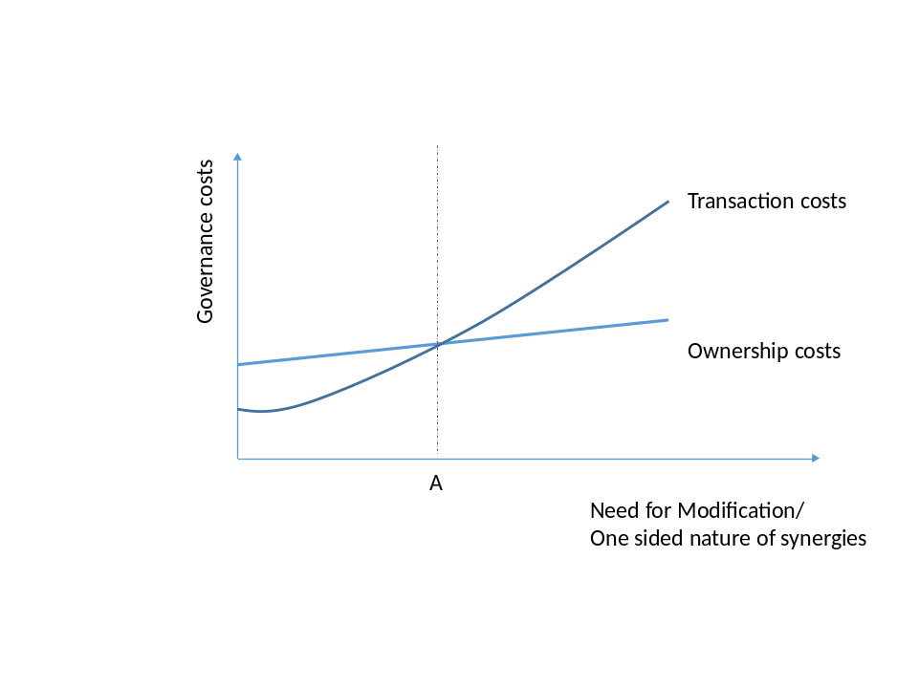
Figure 3.2 Governance structure and synergy characteristics

All else being equal, synergies that are likely to generate significant transaction costs are less likely to be successfully realized in arms-length relationships between independent firms than under common ownership. This result, which has a large body of empirical evidence and rests on the thinking of at least two Nobel laureates in economics, Ronald Coase (1991) and Oliver Williamson (2009), is an extremely useful heuristic for corporate strategists.

Application: WonderWorld
Let’s turn to WonderWorld, our candy maker from the beginning of the Section. They face a choice between an alliance with company A (to co-brand candy) and an alliance with company B (to invest in just-in-time supply). Note that both have the same governance form (alliance)- a relationship between two independent firms. Leaving aside which one could generate more benefits (i.e. assuming magnitudes of potential gains from synergies are comparable), which one is easier to manage? This is akin to asking, where are the governance costs (in this case, since the businesses remain independent, transaction costs) higher?

It seems quite likely that the possible coordination and cooperation failures are greater with company B (just-in-time) than with company A (co-branding). First, for company B since production lines need to be adjusted, more modification is required than for company A (existing brands can be linked), and any modification is harder to unwind for company B than for A (i.e. the effects are one sided). Second, the expected interdependence and need for interaction with company B is higher than with company A, resulting in a greater ongoing need for coordination. For these reasons, we should expect greater transaction costs in B than in A; perhaps the relationship with B should be structured as an acquisition which would bring the business under the common ownership with WonderWorld’s other businesses (or abandoned).

<APPLICATION ENDS>

The three conceptual pillars of corporate strategy
Figure 3.3 illustrates the link between the foundational concepts of corporate strategy: corporate advantage through joint ownership (Section 1), synergies through joint operations (Section 2), and governance costs and governance form (Section 3). In the absence of governance costs, collaboration between two businesses would look the same under common ownership as under separate ownership; a corporate strategist would never outdo an investor, and synergies would always be pursued through joint operation, not joint ownership (II). It is precisely because of governance costs that choice of governance structure has consequences, and sometimes joint ownership and operation of businesses (IV) can extract more value than an investor’s portfolio of the same businesses (III), or the same businesses operated together but owned separately (II). We discuss these ownership choices in detail in the next part of this Document, “Decisions about portfolio composition”, which starts with the next Section.

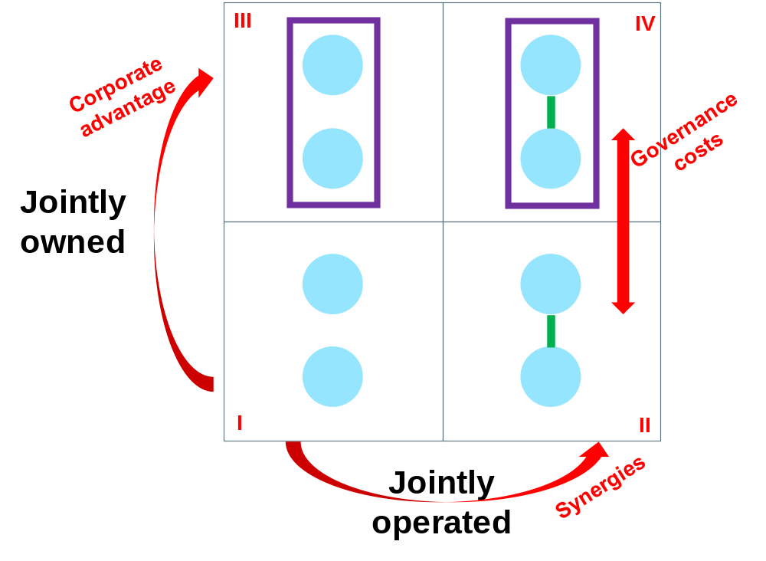
Figure 3.3 Corporate advantage, synergies, and governance costs

Frequently Asked Questions
1. Can governance costs be quantified?
Yes, sometimes they can. For instance, there is evidence that the cost saving from the offshoring of services to countries like India from the U.S. or U.K., results in cost savings that are about 15-to-20% lower than the wage differences, and theis difference can be ascribed to governance costs. For certain frequently occuring and fairly similar types of transactions, it may thus be possible to estimate governance costs. Another approach is to estimate the maximum damage that governance costs can inflict (e.g. our partner cheats and our investment in the alliance has to be written off + the fees of going to court etc.). This might be too aggressive an estimate and would lead to missing out on otherwise viable deals, because the likelighood that the partner will behave oportunistically is not uniformly high. However, even a qualitative understanding of the differences in governance costs under different arrangemnets (e.g. “higher or lower”) can also be enormously valuable to the corproate strategist, to help select the best way to realize synergies. After all, governance costs ideally are to be anticipated rather than (unfortunately) realized; for this reason being able to measure them after they occurred is less important for managers than being able to foresee when they might be large.

Academic background
Much of our understanding of governance costs comes from a body of thinking that is known as the “The Theory of the Firm” in economics and management. The founding father of this theory was Ronald Coase (Nobel Prize winner in 1991), whose ideas have been extended by Oliver Williamson (Nobel Prize winner in 2010). Coase wrote a path-breaking paper in 1937 that raised a very significant question: Why do firms exist at all instead of a series of contracts between individuals who do what they are each best at doing? After all, it was already well known since Adam Smith and David Ricardo that a division of labour based on specialization would increase total value. In the language of synergies, these “gains from specialization”, where both parties are better off when each does what he is better at, would be a form of “Connection” coupled with “Consolidation” (as one of the parties ceases each activity). The question of interest was why contracts were not sufficient to harness these kinds of synergies between businesses. The answer proposed was that governance costs of joint ownership could sometimes be lower than those of managing through contracts (these were termed “transaction costs”). Coase (1937) and Williamson (1975) are useful background for a reader with a deeper ineterst in the intellectual foundations of corporate strategy.

Coase, R. H. (1937). The nature of the firm. Economica, 4(16), 386–405.
Williamson, O. E. (1975). Markets and hierarchies: Analysis and anti-trust implications. New York, USA: The Free Press

For more on the drivers of governance costs in an international context, see:
Ghemawat, P. (2007). Redefining global strategy: Crossing Borders in a world where differences still matter. Boston, USA: Harvard Business School Press.

These are also called hierarchy costs (because of the hierarchical structure of firms).
Williamson, O. E. (1975). Markets and hierarchies: Analysis and anti-trust implications. New York, USA: The Free Press. Williamson, O. E. (1985). The economic institutions of capitalism. New York, USA: The Free Press. Gulati, R., Lawrence, P. R., & Puranam, P. (2005). Adaptation in vertical relationships: Beyond incentive conflict. Strategic Management Journal,26(5), 415–440.
Vanneste, B. S., & Frank, D. H. (2014). Forgiveness in vertical relationships: Incentive and termination effects. Organization Science, 25(6), 1807-1822.

